**Nama : Muh Zaidan Fauzan**

**NIM : 1104220063**

**Spectrogram Example**

**Source Code :**

import numpy as np

import sounddevice as sd

import matplotlib.pyplot as plt

plt.rcParams['figure.figsize'] = [12,8]

plt.rcParams.update({'font.size' : 18})

dt = 0.001

t = np.arange(0,2,dt)

f0 = 50

f1 = 250

t1 = 2

x = np.cos(2*np.pi*t*(f0 + (f1 - f0)*np.power(t,2)/(3*t1**2)))

fs = 1/dt

sd.play(2*x, fs)

plt.specgram(x, NFFT=128, Fs=1/dt, noverlap=120, cmap='jet_r')

plt.colorbar()

plt.show()

**Spectrogram :**

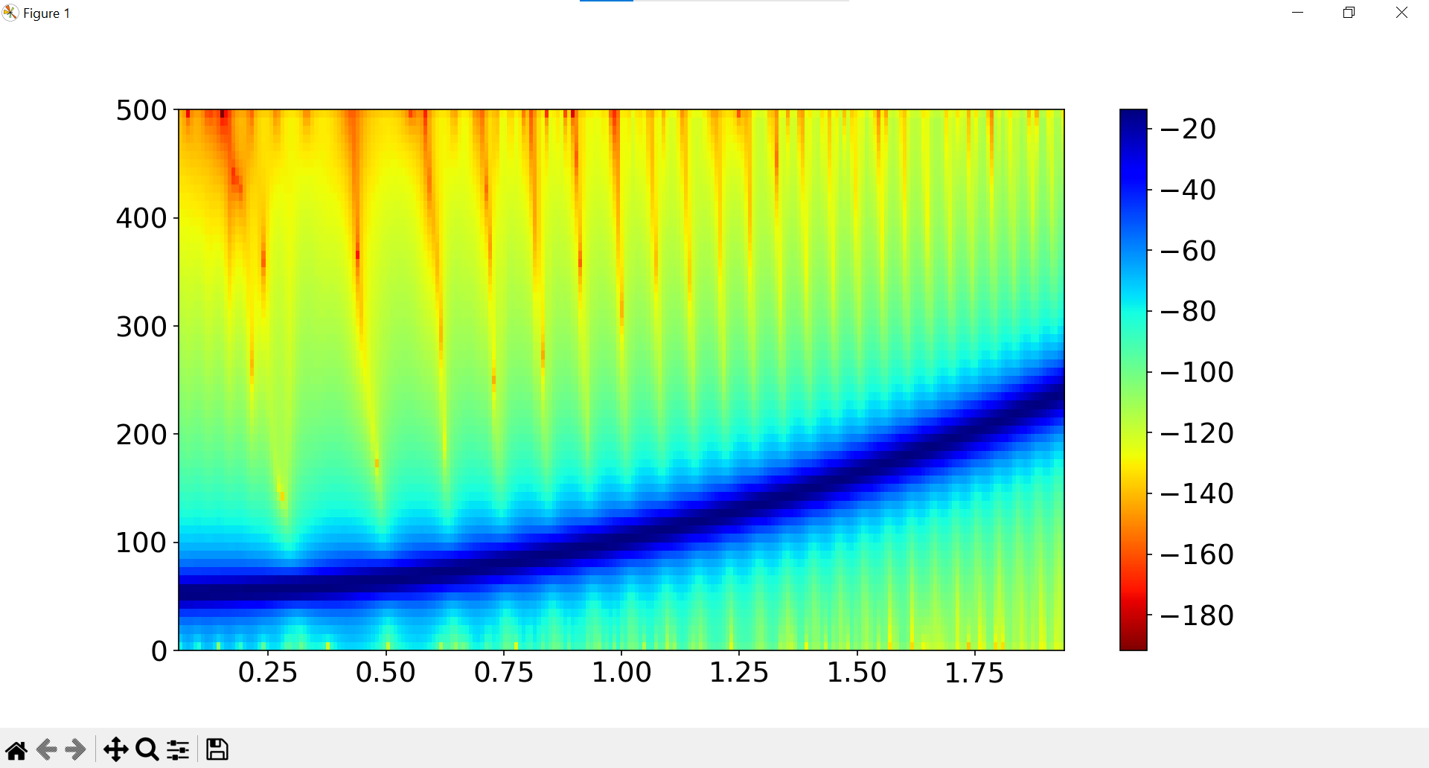

**Link Rekaman Suara :** <https://github.com/user-attachments/assets/fd6391a3-b843-402e-a5b9-ca8089028be8>

**Link Full Source :** <https://github.com/Zaidanfzn/Spectrogram>